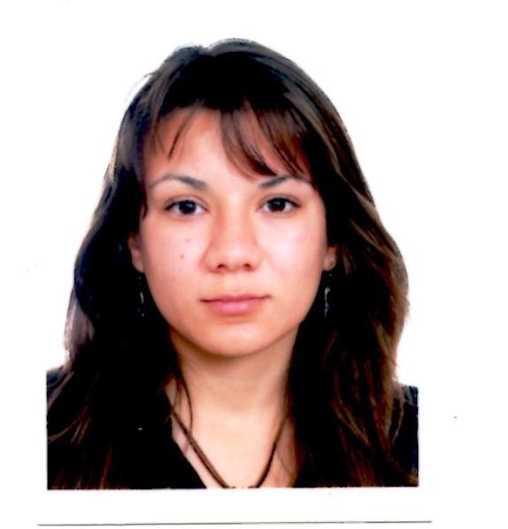**RIM HAYAT CHAIF**

*City ittifak- remchi – Tlemcen*

*13500, Algérie*

*00213.556.51.88.24*

*Chaif_rim1990@hotmail.fr*

*21/08/1990.Tlemcen, Algérie*

*24 years old, Single*

*Driving license*

**Professional Experiences**

**From 20 August until now: Global Voices website**

        Translator English / French to Arabic

<http://ar.globalvoicesonline.org/2014/09/02/35178/>

**From 21 July until now: Senior Blaster on the website Blasting news**

Write and correct articles in French

<http://fr.blastingnews.com/divertissement/2014/08/le-mariage-a-tlemcen-un-des-grandes-ceremonies-qui-fait-tourner-toutes-les-tetes-00115878.html>

**Trainings** 

**From 01 July 2014 until now:** online training at Dar Al hayat.

**From 02 to 05 September 2014: internet governance forum at International Convention and Exhibition Center (ICEC) in Istanbul - Turkey.**

Attend conferences and participate in workshops on internet governance and freedom of speech

**From 03 to 06 June 2014: Workshop held in Alt city Beirut-Lebanon**

Training on Internet governance and policy in the Middle East and North Africa.

**From April 25 to July 05: Training at the Center of the electronic media Remax - Algiers - Algeria**

                        Creating a blog / Write articles and post them on the blog

  RSS Service / analyze the content of news sites

**2014: Private School Active Training - Algiers Algeria**

English course: B1-2 level / B2-1

**From April to June 2013: International Press Center**

                         Animation of a TV show / Make video reports

**From one to 15 December 2012: Training in an Algerian Newspaper “liberté”**

                          Write articles on the cultural section

**From 20 September to 2 October 2012: Training at the private TV channel chourok TV**

                        Write off / Making sound

**From three to 22 July 2010: institute French- Tlemcen- Algeria**

Diploma in oral expression - French / 30h /

|  |  |
| --- | --- |
| **Qualification** | **s** |



**2011-2014: National School of Journalism and Sciences of Information - Algiers - Algeria**

             Two-year master degree in institutional and business journalism a year to prepare the dissertation study under the theme (Challenges and prospects of e-commerce in Algeria)

**2008-2011: University Aboubakre Balkaid - Tlemcen - Algeria**

                       Degree in Business French

**2010: High School Mohamed Daoud Djabli - Remchi - Tlemcen - Algeria**

                       Bachelor, natural science and life

**2008: High School Mohamed Daoud Djabli - Remchi - Tlemcen - Algeria**

                           Bachelor, natural science and life

**Computer Skills**: 

Fluency: Word, Publisher, Powerpoint, Excel, Photoshop, prezi, Corel, moviemaker, Linux

**Language skills** 

English: intermediate (Diploma B1.2) / French: advanced (Diploma Delf B2 and DALF Diploma: C1) / Arabic: mother tongue / Spanish: elementary

**Sports and Leisure**

Travel / reading / Theatre (1 years of practice, national competition) / Sport Full contact kickboxing (Two years of practice)